Task 4
Smoking Status vs Age at Diagnosis

- Are smokers diagnosed with lung cancer at a younger age compared to non-smokers?
- Compare age distributions across smoking categories using boxplots or summary statistics.

Output

- Terminal (Summary Statistics)

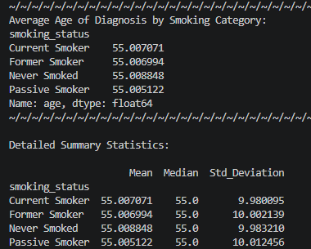

- Boxplot
